Assignment I
Note:
- For all assignments, you can either work alone or work in teams of 2-3 persons. The maximum number of students in a team is 3. If you decide to collaborate with others, please make sure that EVERY team member has contributed to this assignment and knows how to solve EACH question.
- When you submit your hard copies in class, please be sure that your name(s) and student number are included.

Please refer to the Human Development Index data provided by the instructor.

Variables of the dataset are defined as follows:
Human Development Index (HDI) in 2013: A composite index measuring average achievement in three basic dimensions of human development—a long and healthy life, knowledge and a decent standard of living.
Life expectancy at birth: Number of years a newborn infant could expect to live if prevailing patterns of age-specific mortality rates at the time of birth stay the same throughout the infant’s life.
Mean years of schooling: Average number of years of education received by people ages 25 and older, converted from education attainment levels using official durations of each level.
Expected years of schooling: Number of years of schooling that a child of school entrance age can expect to receive if prevailing patterns of age-specific enrolment rates persist throughout the child’s life.
Gross national income (GNI) per capita: Aggregate income of an economy generated by its production and its ownership of factors of production, less the incomes paid for the use of factors of production owned by the rest of the world, converted to international dollars using PPP rates, divided by midyear population.
Human Development Index (HDI) in 2012.
Levels of human development: A nominal variable showing levels of human development based on the Human Development Index in 2013
Regions: The geographical regions of countries: 1. North America 2. South America 3. Oceania 4. Others
- What is the unit of analysis for these variables associated with human development?
The unit of analysis is country.

- What are the levels of measurement of all the variables listed above?

Human Development Index (HDI) in 2013 | Ordinal
Life expectancy at birth | Interval-ratio
Mean years of schooling | Interval-ratio
Expected years of schooling | Interval-ratio
Gross national income (GNI) per capita | Interval-ratio
Human Development Index (HDI) in 2012 | Ordinal
Levels of human development | Nominal??email: Why is this nominal and not ordinal
Regions | Nominal

- Please generate the frequency distribution (a table) for levels of development (variable: lvl_development) and briefly describe it. Both the Stata command and output must be included in your answer.

>> tab lvl_development

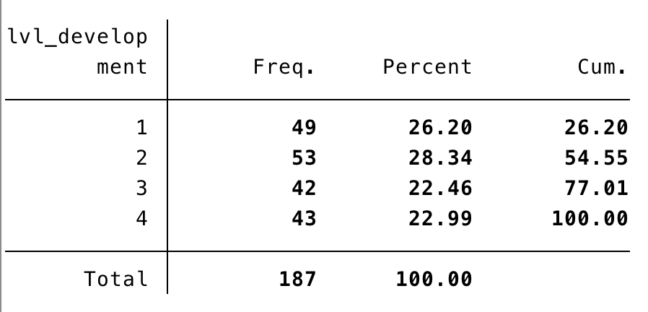
Figure 1. levels of development frequency table

As seen in the above table, each category has about the same number of countries in it, with lower levels (1 and 2) having a higher frequency.

- Please generate a histogram for gross national income per capita and briefly describe it. Both the Stata command and output must be included in your answer.

>> histogram income_per_capita, frequency width(10000)
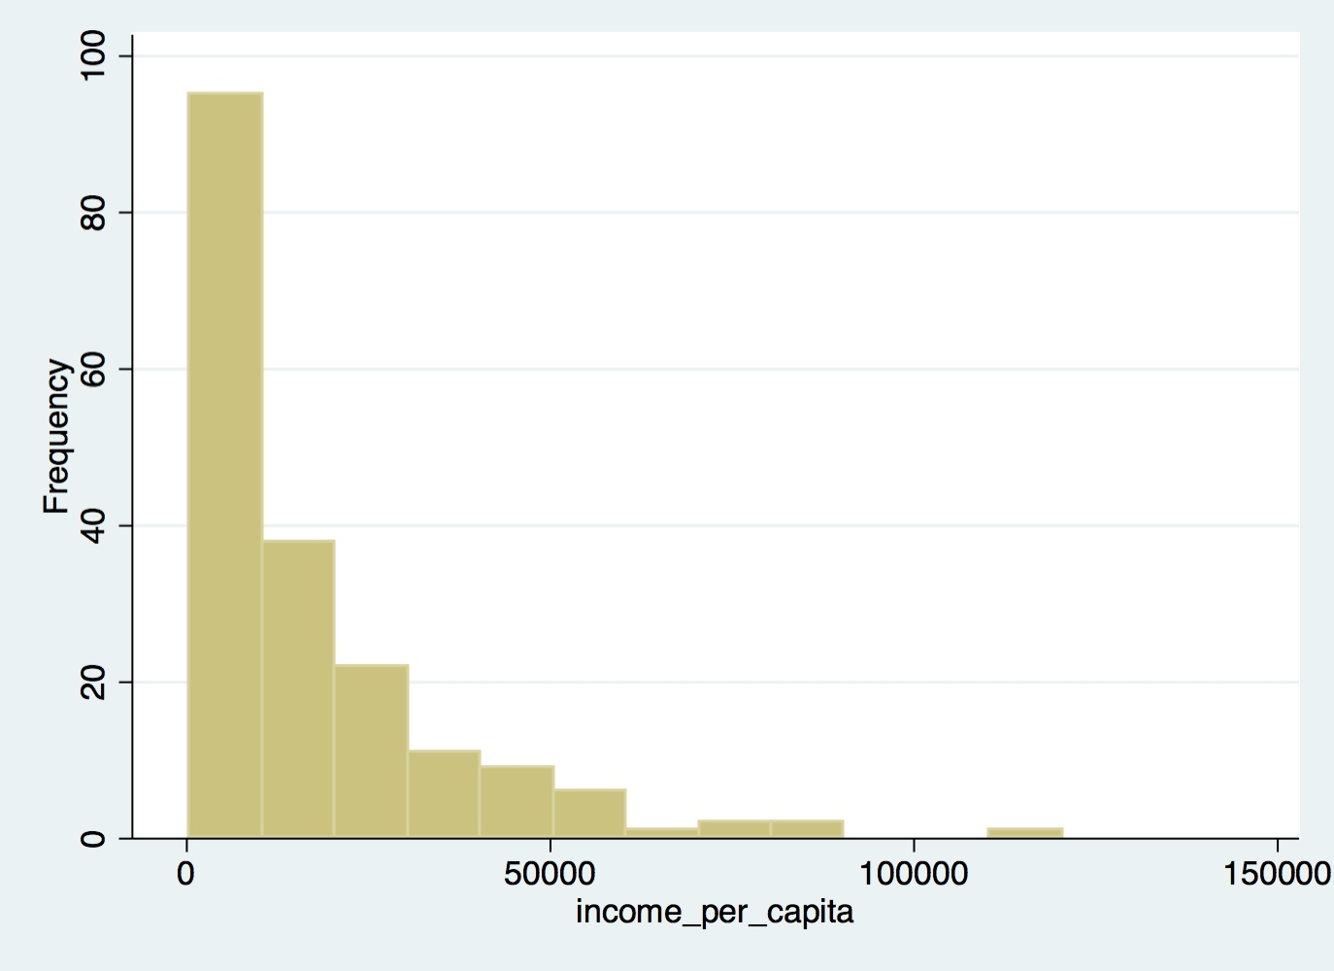
Figure 2. Histogram for gross national income per capita

The above histogram shows that the income level is skewed towards the high income levels. This means that most of the countries have lower income level, with some countries at a much higher income level than the majority as shown by the tail in the above graph.

- Please calculate the mean, variance, median and standard deviation of national income per capita. Based on your answer to question 3 and 4, is this distribution skewed? If yes, is it right-skewed or left-skewed? Is it possible for you to transform the variable of national income per capita and greatly reduce the skewness? Please illustrate how the skewness is reduced after data transformation. Both the Stata command and output must be included in your answer.

>> tabstat income_per_capita, stat(n me med ma mi ra sd iqr)

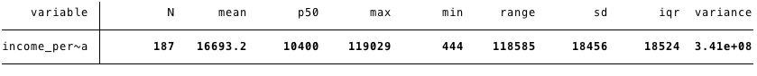

Yes, the income distribution is skewed to the right as seen in parts 3 and 4. Because the tail of the graph in part 4 indicates that there are outliers at the far right that bring the average income to a higher level than the median income we conclude that the distribution is skewed to the right.

>> histogram income_per_capita, frequency width(100000)
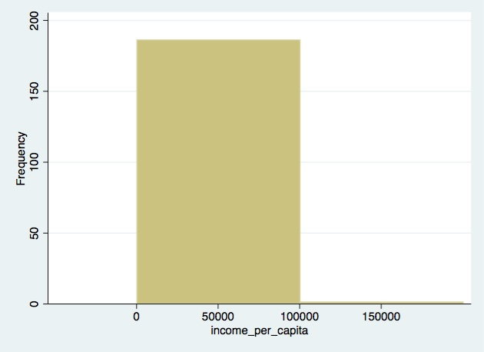

As seen in the above graph, by increasing the bracket size for different income levels, we have reduced the resolution of the data. This in turn has produced a symmetric (non-skewed) graph with the majority of data in the center and about the same amount of data on the far right and far left.
Another way to get a dataset that is not skewed would be to recode the national income variable into different levels of income that don’t have the same interval size. For example, we could have smaller interval size for lower income brackets and larger intervals for higher income brackets, therefore making this new variable (income bracket) symmetric.
[add command and graph if we have time]

- Please create a pie chart based on the variable regions and briefly describe it.
[ask TA or prof about what do the numbers for variable regions mean? 0,1,2,3]

>> graph pie, over(regions) plabel(_all percent)
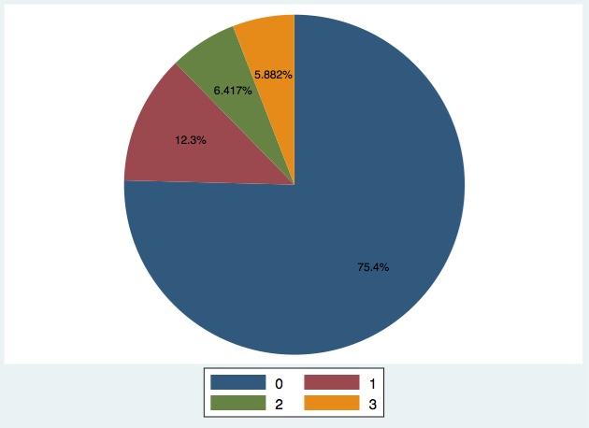

The above pie chart shows what percentage of countries are in each region. (i.e. this chart shows the distribution of countries in the four different regions) Each region is specified by a code (number) between 0 and 3. [ask the teacher or TA if you should explain what is each number for example 0 >> Europe?? ]

- Please create a box plot for HDI in 2013 and another box plot for HDI in 2013 by levels of human development. Both the Stata command and output must be included in your answer.

8. The Department of Sociology reports that the average GPA of its undergraduate students is 2.8 with a standard deviation 0.3.

8.1 What is the Z score for a student whose GPA is 3.4?

8.2 Please calculate the proportion of students whose GPA is between 2.0 to 3.0. (Please keep two decimal places and you may need to use to the tables below)

8.3 Please calculate the proportion of students whose GPA is above 3.0.

8.4 If students with top 10% GPA ranking can be admitted to the Sociology Honours program, what should be their GPA requirement?

